**Test 1:**

Training:

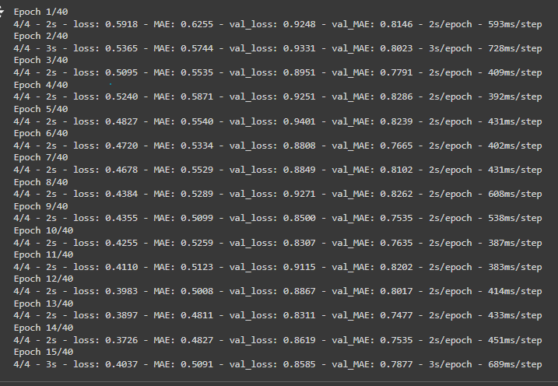

Test predictions:

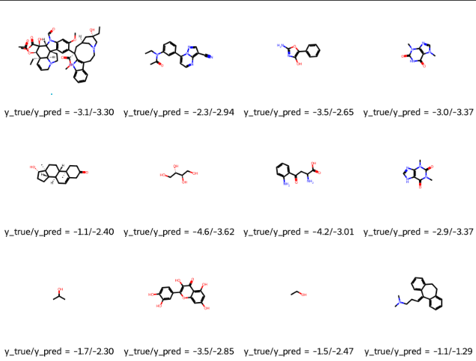

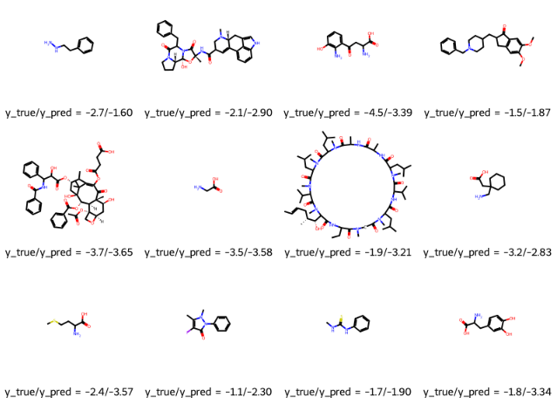

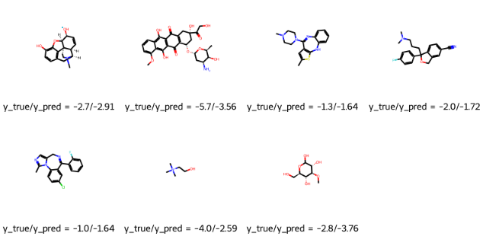

Loss:

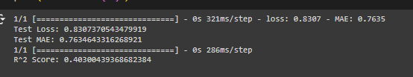

Plot:

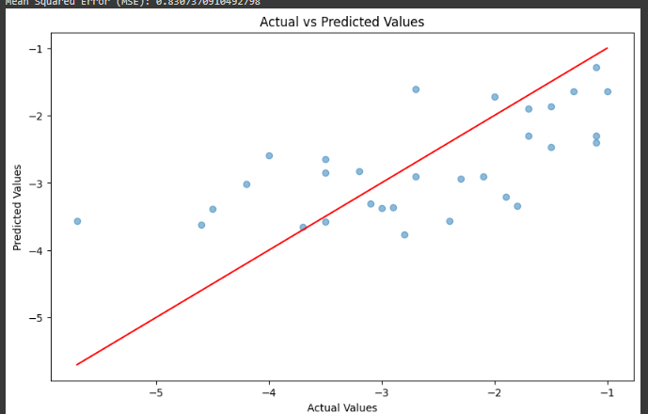

**Test 2:**

Training:

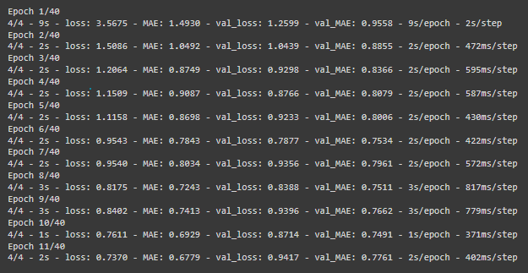

Test predictions:

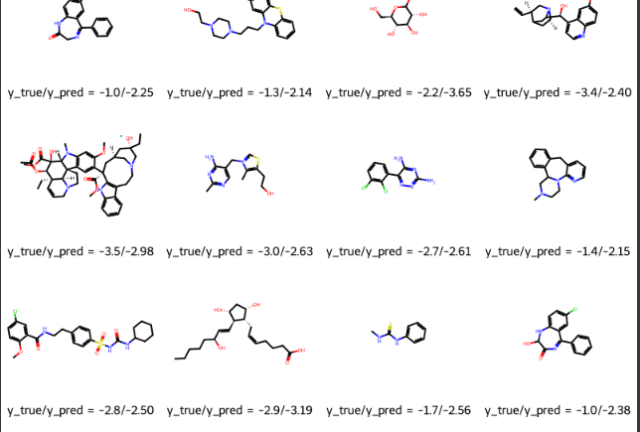

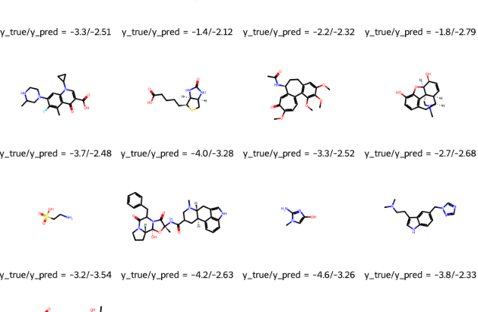

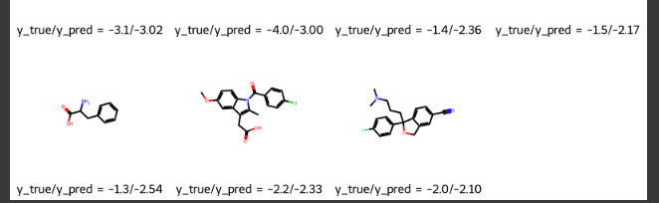

Loss:





Plot:

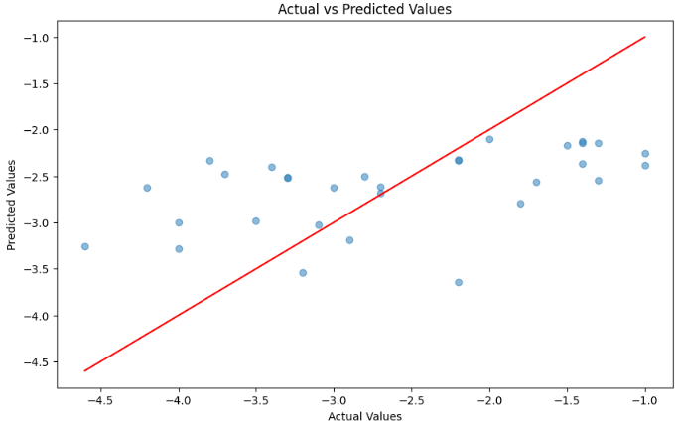

**Test 3:**

Training:

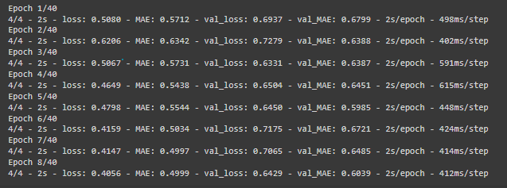

Test predictions:

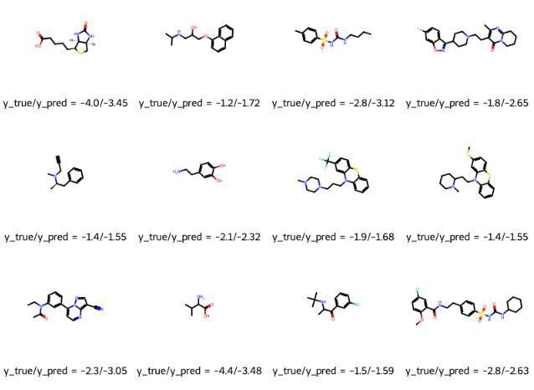

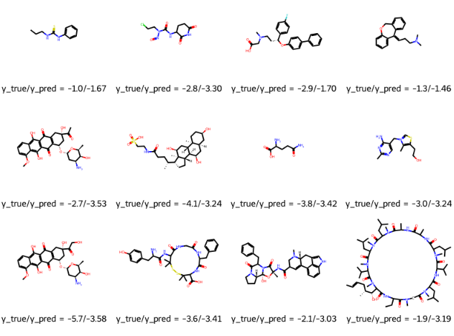

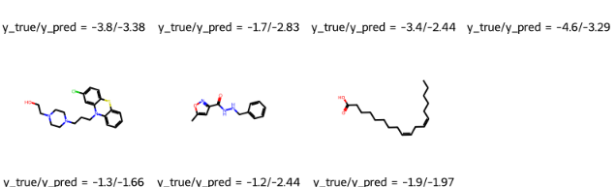

Loss:

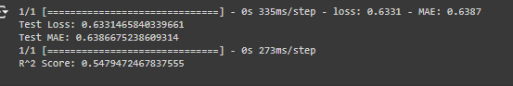

Plot:

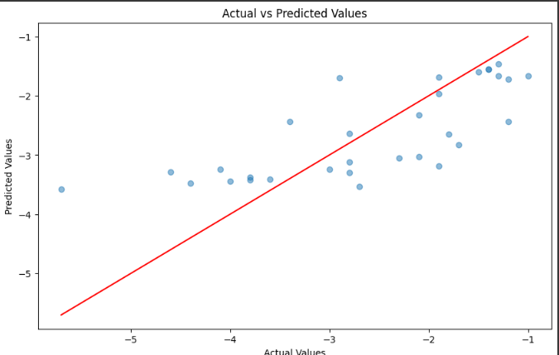

**Test 4:**

Training:

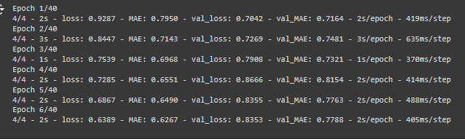

Test predictions:

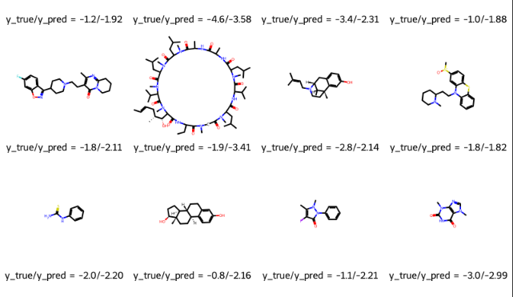  
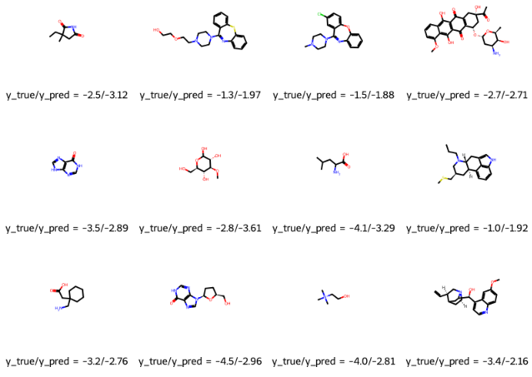

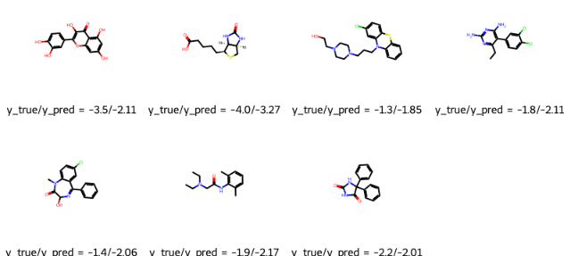

Loss:

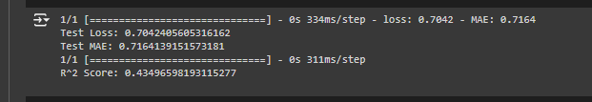

Plot:

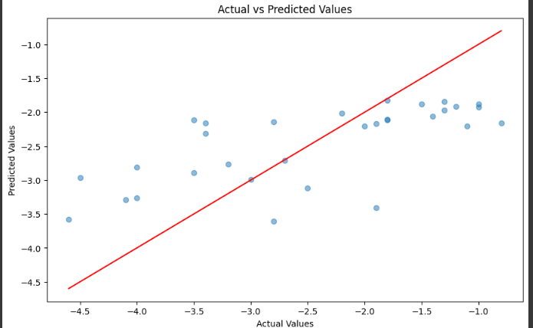

**Test 5:**

Training:

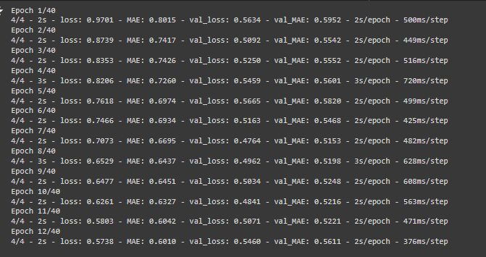

Test predictions:

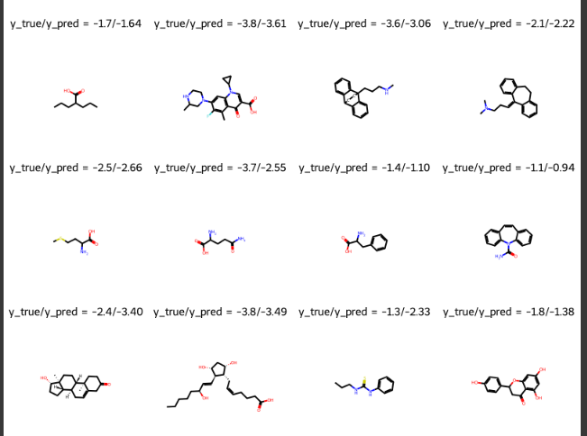

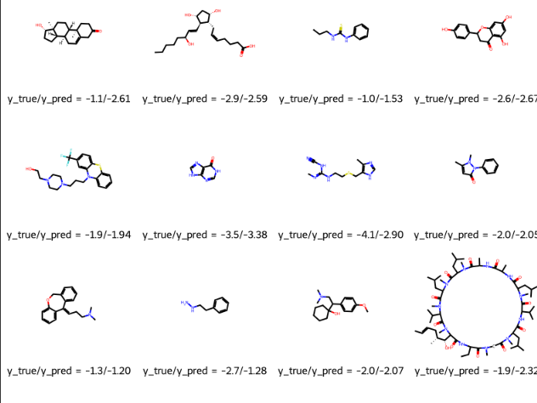

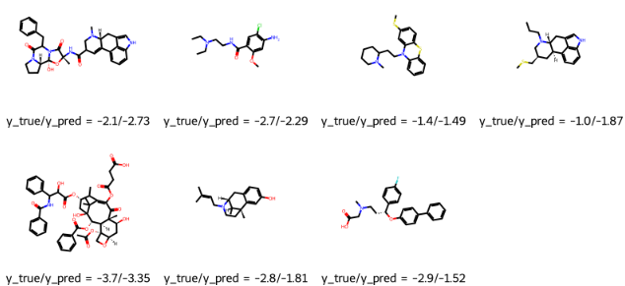

Loss:

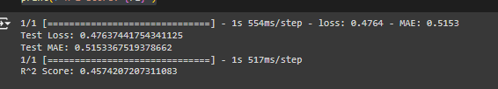

Plot:

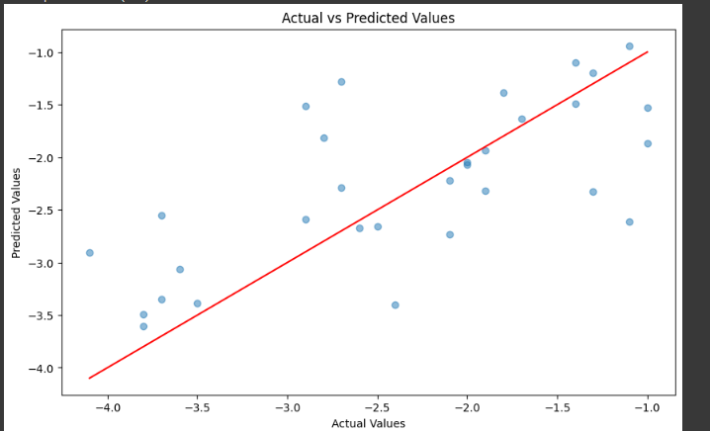

|  |  | Train | Train | Test | Test |
| --- | --- | --- | --- | --- | --- |
| Atom Features | Bond  Features | MAE | R square | MAE | R square |
| 1. Symbol 2. N_valence 3. N_hydrogens 4. Hybridization 5. Atomic_number 6. Formal_charge 7. Degree 8. Implicit_valence 9. Is_aromatic 10. Atomic_mass 11. Vdw_radius 12. Partial_charge 13. Is_in_ring 14. chirality | 1. Encode 2. Bond_type 3. conjugated | 1. Mean 5 test 2. 95% CI |  |  |  |
|  |  | 1. 0.5771 | 1. 0.5659 | 1. 0.5998 | 1. 0.5391 |

TRAIN

mae

1. 0.7186810374259949
2. 0.5475955605506897
3. 0.5239328742027283
4. 0.5467827320098877
5. 0.5488945245742798

TRAIN

R square

1. 0.38282373395650904
2. 0.6228270751969072
3. 0.5888917195140355
4. 0.620849016841249
5. 0.6143636687108813

TEST

mae

1. 0.5992833971977234
2. 0.6275594234466553
3. 0.7083663940429688
4. 0.46053415536880493
5. 0.6035997867584229

TEST

R square

1. 0.39973028704701086
2. 0.45074850406599065
3. 0.5955871935515469
4. 0.693195470433716
5. 0.556484974889141

Less features:

TRAIN

Mae

1. 0.7203178405761719
2. 0.3999626338481903
3. 0.5201322436332703
4. 0.5673905611038208
5. 0.5499542951583862

TRAIN

R square

1. 0.359920706741121
2. 0.7706451475136914
3. 0.592567986988253
4. 0.6121047610289767
5. 0.5990919068034906

TEST

Mae

1. 0.6249377131462097
2. 0.6453763842582703
3. 0.5482165813446045
4. 0.41134268045425415
5. 0.5951535105705261

TEST

R square

1. 0.36994569331753535
2. 0.43956781795531463
3. 0.7300202188773806
4. 0.7839749303910667
5. 0.5529128444788813